Blogging

01 Expectations & Github Pages

Contents

2 Blogging 1

2.1 Basic expectations 1

3 Github pages 2

3.1 Setting up DNS 2

3.2 Important notes 2

4 Links 3

# Blogging

Github pages allows you to host static sites, so it’s an ideal hosting for blogs!

Static sites are easy to create via static site generators:

* Jekyll
* Hugo
* Gatsby

## Basic expectations

HTML

1. Fluent / Responsive HTML – work on every device
2. Template based on Bootstrap 5 (with the basic BS color variables)

Content:

1. Landing page
2. Combined with some other layout for blogging / content / docs
3. Mix blog and other kind of static docs

Functionality:

1. search capability
2. social share
3. tagging, categorizing (taxonomies)
4. auto TOC generator (on the sidebar, beside a post)
5. code highlighting
6. RSS

Extras:

1. pinned items
2. auto publish based on date: daily build process on github - <https://jasonet.co/posts/scheduled-actions/>

# Github pages

## Setting up DNS

<https://docs.github.com/en/github/working-with-github-pages/managing-a-custom-domain-for-your-github-pages-site>

DNS entry:

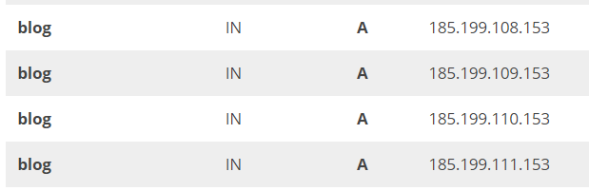

Github:

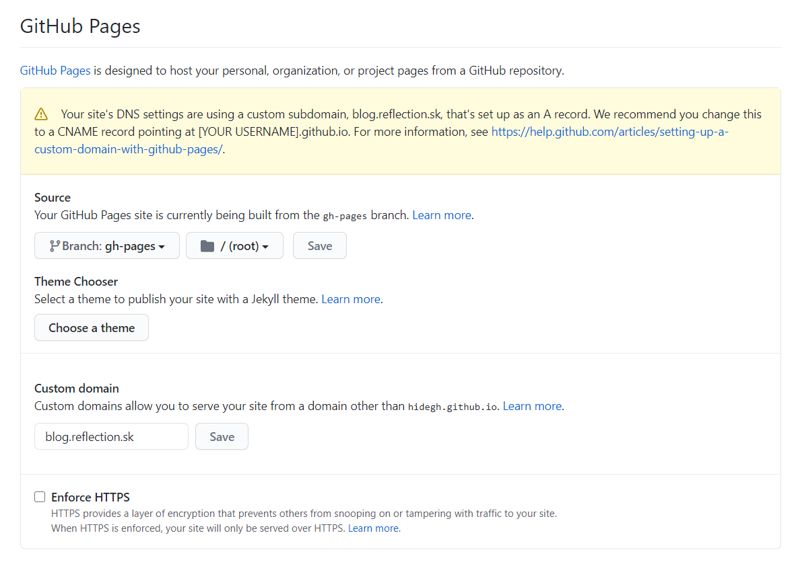

## Important notes

Must set the source branch to gh-pages (after the build finishes) – but before that we need to configure Jekyll (see: 5.2), push the changes, wait until the Github action finishes…

Other tools might use a different branch name.

**Also we can have a private repository and push fom there into the public github-pages repo (not sharing the MD content)!**

# Links

<https://www.blogherald.com/guides/content-licensing-101-for-bloggers/>

**There are many useful tools for blogging, will create a blog-post on it.**